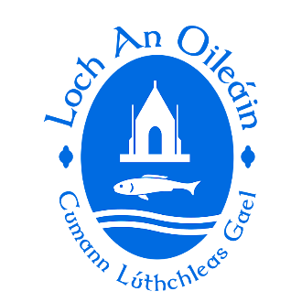

LOUGHINISLAND GAC 2023 AGM – MONDAY 27th NOV. 2023

NOMINATION FORM FOR ELECTING 2024 EXECUTIVE COMMITTEE

Club Constitution - The Executive Committee shall be comprised of the Chairperson, Vice- Chairperson, Treasurer, Registrar, one player’ representative and at least five full members.

Further to decision at National Congress 2011, the posts for Children’s Officer and Designated Child Protection Officer shall be appointed by the Executive Committee.

Nominations can only be made by members.

COMMITTEE  POSITION | OFFICE HOLDER 2023 | NOMINATION FOR 2024 EXECUTIVE COMMITTEE
Chairperson | Louise Kearney
Vice Chairperson | Jim Carvill
Secretary | Jonathan Turley
Assist. secretary | Shauna McCabe
Fixtures Secretary | Sarah Murray
Treasurer | Benny Corrigan
Assist. Treasurer | Peter Cochrane
PRO | Brenda Torney
Registrar | Nuala Holland
Development Officer | Paul McMullan
Children’s Officer | Bronagh Mason | *not elected at AGM*
Cultural Officer | Catriona Morgan | *not elected at AGM*
County Board Rep. | Brendan Kearney
Healthy Clubs Officer | Helen Rice
Players Rep. Men | Declan Valentine
Players Rep. Ladies | Eimear Murray
Youth Officer | Caroline O’Hare
Coaching Officer | Peter Fitzpatrick
Add Committee Members | Gerry Toman
 | Raymond McClements
 | Ryan Lawlor
 | Sean Digney
 | Vincent McGlew
 | Gerry Morgan
 | Alan Molloy
 | Seamus Savage
 | Eimear Murray
 | Eilish Gallagher

NAME_ _ _ _ _ __ _ _ _ _ _ _ _ _ _ _ _

MOTIONS

Type below

(proposed motions may be amended by committee to comply with GAA regulations)

