Foireann is the new GAA games management system for registration and membership.
If you were part of Return to Play last year it will look familiar. It is linked to your account to make it easy to access. Log in at http://returntoplay.gaa.ie/ and you will see all the new features.
If you were not involved in playing or are registering yourself or your child for the first time you will need to set up a Foireann account. Click on this link to show you how to set up Foireann. https://gmssupport.zendesk.com/hc/en-gb/articles/360018872740-SCREENCAST-Accessing-Foireann-
We understand that you may be the parent of a member, and not registering yourself. That is fine, just follow the steps that work for your household. Obviously, we would love everyone to be a member so we have developed an all-new Premium Blue package that may be of interest to you.

- The first step is to register all those who want to be members. You are covered through the Profile section, and then you add the rest. Use the Family tab to help guide this.

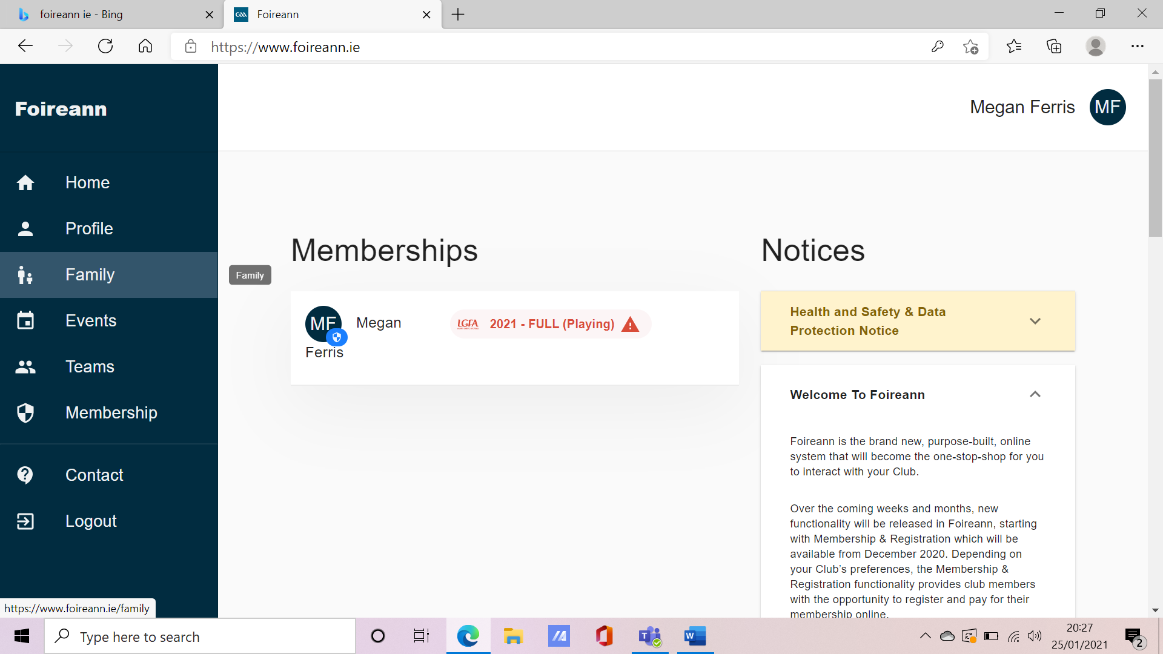

- Once you have everyone’s details submitted, please move to the Membership tab which will guide you to which membership package suits your household.

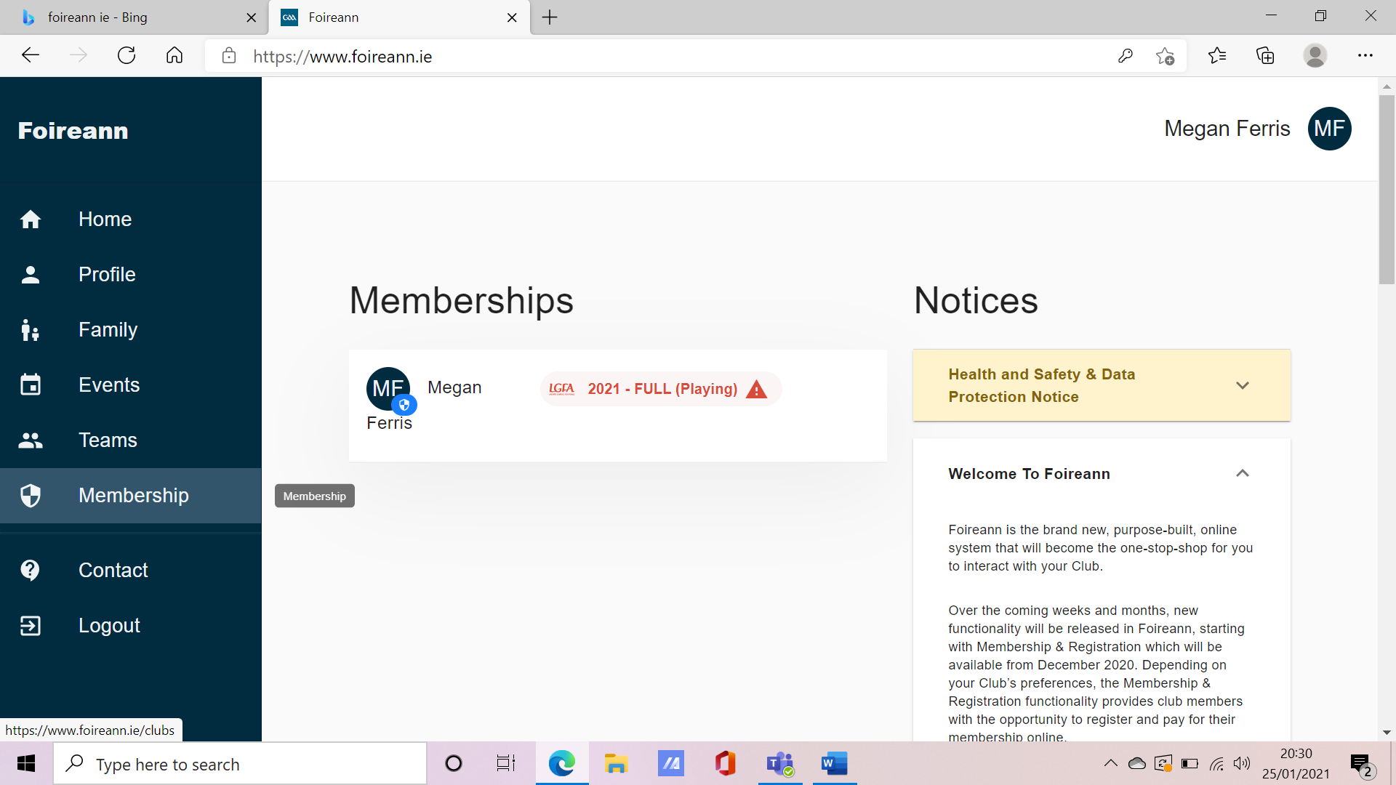

- You will see all the available membership options – this must be updated with changes made on the day of registration
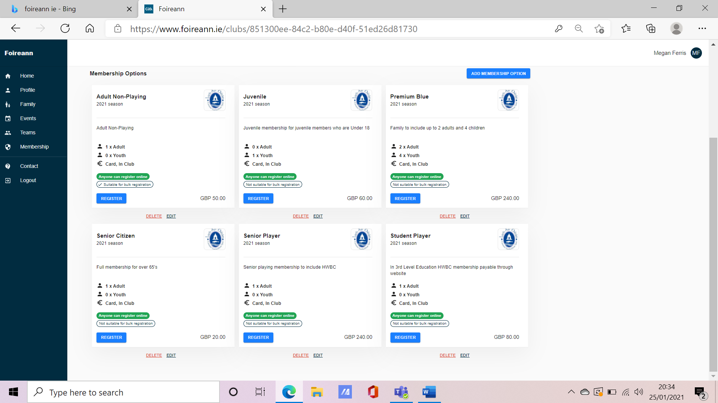

- Please select your preferred option and put in the names of all those who you wish to include.
For each person you will be asked to allocate them to GAA or LGFA, player or non-player.
We are awaiting advice on how to register coaches of female teams, will update accordingly.
- Once you have named everyone to be included you will be asked to select your preferred payment option.

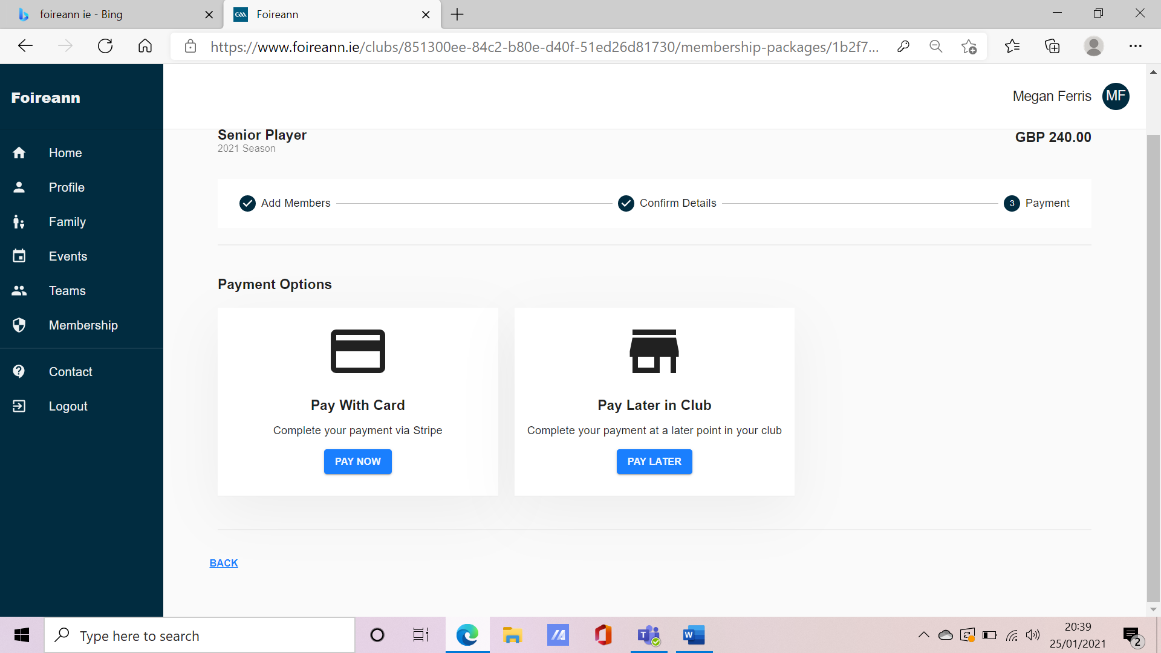

If you wish to make one payment to cover all your membership for 2021, please select ‘Pay With Card’. You will be taken to the payment page.
If you wish to pay monthly instalments, please select ‘Pay Later in Club’. You will then need to go to the Membership section on the Club website and complete the relevant section. Click here https://loughinislandgac.com/membership/
You may already pay through standing order. If this is the case, please select ‘Pay Later in Club’. You do not need to take any further action as the standing order will continue. We will contact you to confirm any changes to include adding of second adult member and lotto numbers.
If there are any queries or you have any issues please email me at meganferris97@icloud.com or contact any committee members. We shall be back to you as soon as possible.

