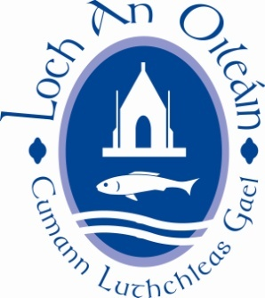

LOUGHINISLAND GAC AGM 26th NOV. 2020

NOMINATION FORM FOR ELECTING 2021 EXECUTIVE COMMITTEE

COMMITTEE  POSITION | NOMINATION FOR 2021 EXECUTIVE COMMITTEE
Chairperson
Vice-Chairperson
Secretary
Assist. Secretary
Fixtures Secretary
Treasurer
Assist. Treasurer
PRO
Registrar
Development Officer
Children’s Officer
Cultural Officer
County Board Rep.
Healthy Clubs Officer
Players Rep. Men
Players Rep. Ladies
Additional Committee Members

- The Executive Committee including the Players’ Representative, shall be elected by the Full Members present, entitled to vote and voting at the Annual General Meeting. Exceptions: The Children’s Officer and the Officer for Irish Language and Culture shall be appointed at the Annual General Meeting on the recommendation of the outgoing Executive Committee. The Youth Officer(s) will be appointed at the first meeting of the new Executive Committee

NAME_ _ _ _ _ __ _ _ _ _ _ _ _ _ _ _ _

MOTIONS

Type below

(proposed motions may be amended by committee to comply with GAA regulations)

