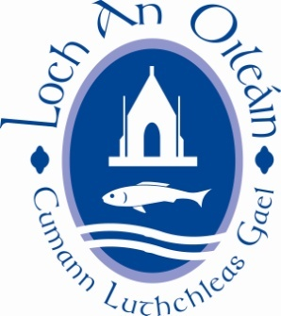

LOUGHINISLAND GAC AGM 26th NOV. 2020

NOTES

Dear member

- Our Annual General meeting will be held on Thursday 26th November 2020. Unfortunately, due to the continued instruction from the GAA that all Club.
- Premises shall remain closed for the foreseeable further our AGM will be held interactive by Microsoft Teams. More information on this means of holding will be issued closer to the date of the AGM.
- As passed at last year’s AGM I have included a form that indicates the intention of all this year’s Executive Committee regarding re-election to 2021 Executive Committee.
- It should be noted that, in order, for a person to be considered for a post in the new Executive Committee that person needs to be nominated by 2 different full club members. Also, the person nominated must be a full member of the Club.
- In order that we have a democratically elected committee I would urge all members to complete nominations and return the form along with any motions to the Secretary (secretary.loughinisland.down@gaa.ie) before 2nd November 2020.

