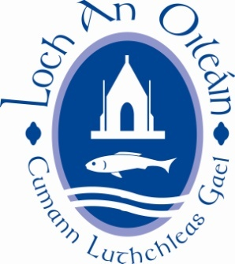

LOUGHINISLAND GAC AGM 28th NOV. 2019

NOMINATION FORM FOR ELECTING 2020 EXECUTIVE COMMITTEE

COMMITTEE  POSITION | OFFICE HOLDER 2019 | NOMINATION FOR 2020 EXECUTIVE COMMITTEE
Chairman | Seamus Fay
Vice Chairmen | Aaron McKeown
 | Peter Fitzpatrick
 | Declan Valentine
Secretary | Gerry Morgan
Assist. Secretary | Michael Cochrane
Treasurer | Benny Corrigan
Assist. Treasurer | Jonathan Turley
PRO | Helen Rice
Registrar | James Campbell
Development Officer | Paul McMullan
Children’s Officer | Bronagh Mason
Cultural Officer | Jean O’Neill
County Board Rep. | Vincent McGlew
Healthy Clubs Officer | Pat McGreevy
Players Rep. Men | Jonny Flynn
Players Rep. Ladies | Rebecca McKelvey
Youth Officer | Rory Mason
 | Kirsten Jennings
Additional Committee Members | Gerry Toman
 | Eilish Gallagher
 | Raymond McClements
 | Jim Carvill
 | Julie Digney
 | Sean Digney
 | Seamus Savage

NAME_ _ _ _ _ __ _ _ _ _ _ _ _ _ _ _ _

MOTIONS

Type below

(proposed motions may be amended by committee to comply with GAA regulations)

